Trinity Character Education
Pupils got involved in a variety of activities during our first Flexi Day of this academic year. With a Black History Month and relationships theme, we focused on diversity within our Trinity Community. Both staff and pupils dressed in clothes which represents their cultural identity and pupils enjoyed drop down lessons where they had a chance to work with different pupils and teachers to their normal curriculum day.
Year 7 looked at our relationships with each other through performance poetry while year 10 discussed healthy relationships which included keeping themselves safe on social media. Year 9 enjoyed a visit to Tate Modern. They started their day with an insight into the history of the Tate, the architects who designed it and the variety of rooms and exhibition spaces it has to offer. Year 8 spent the day in the Maths department looking at our relationship with money and how effective financial planning allows us to feel in control and confident in managing our day to day and long term finances. Year 11 were busy in the Science department, working in teams, conducting experiments, and getting through some valuable GCSE syllabus requirements at the same time.
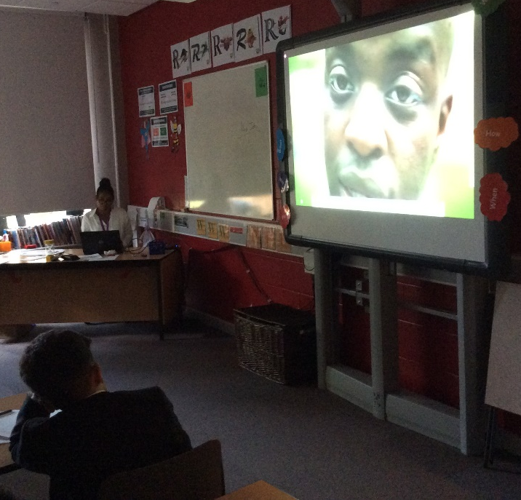
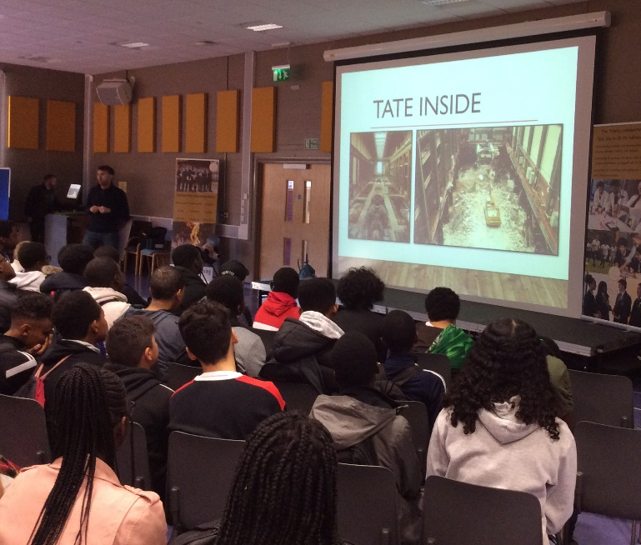

Year 9 learn about the history of the Tate before their visit.

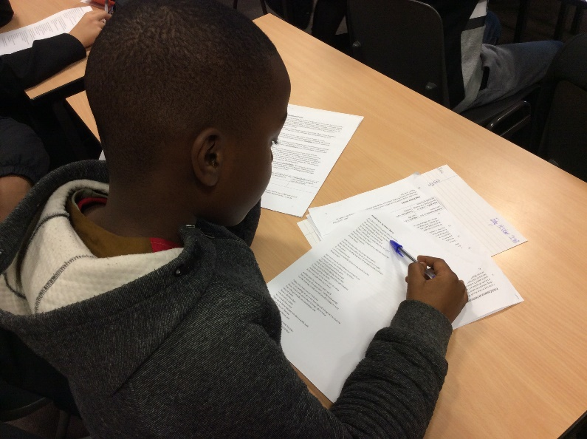
Year 7 hear about attitudes to London from George the Poet.

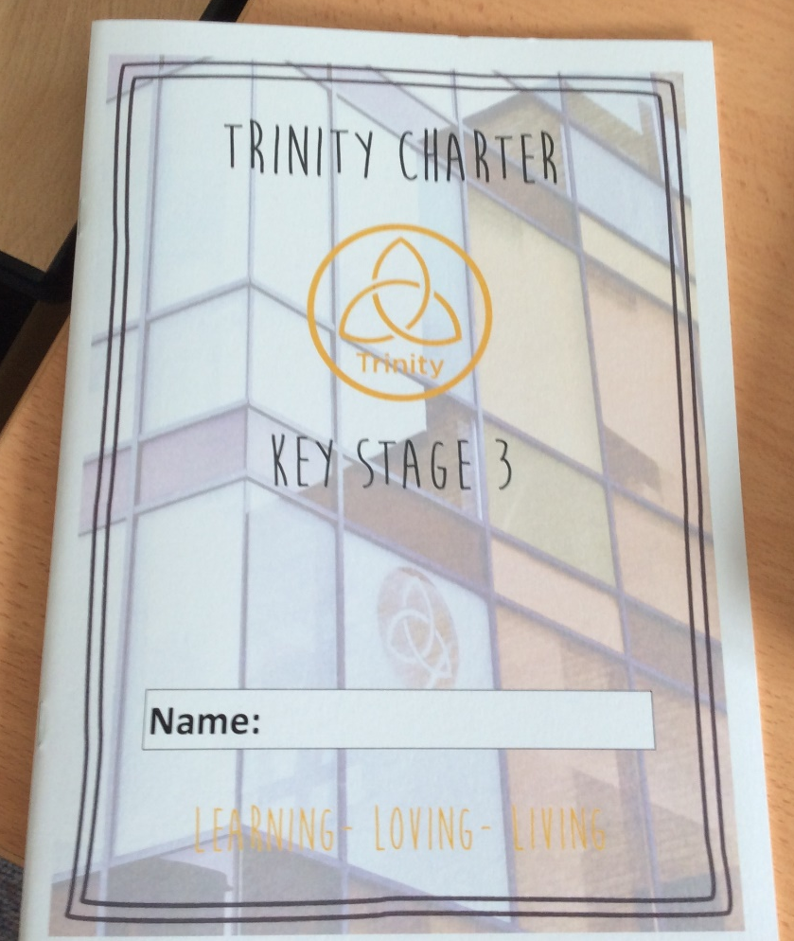
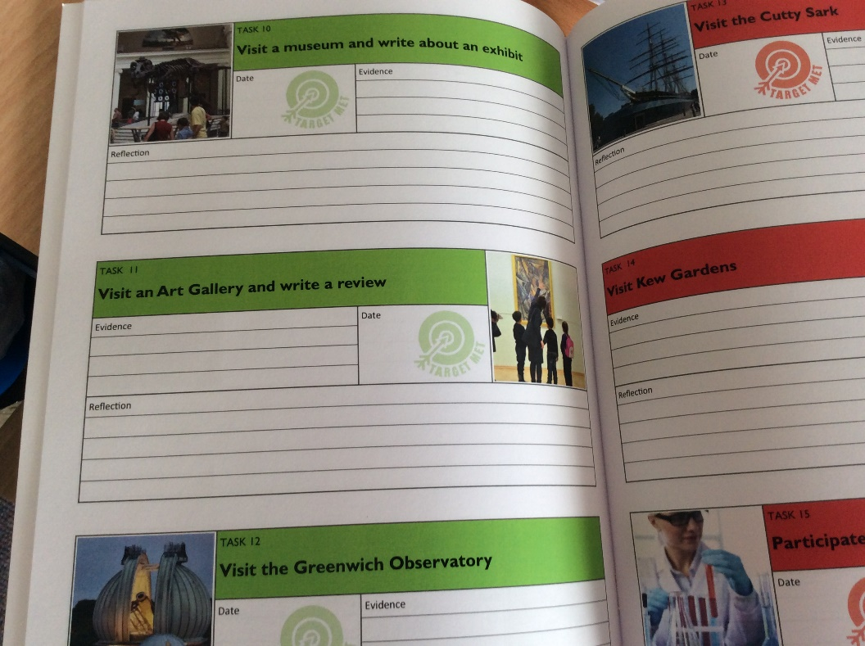
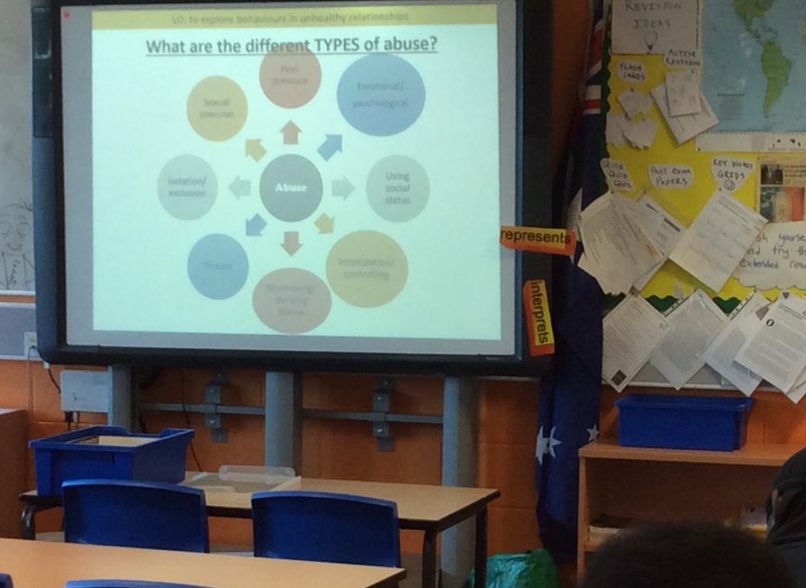
Thinking about our relationship with money in year 8 Flexi Day sessions.
Thought provoking questions and challenging discussions with year 10.

